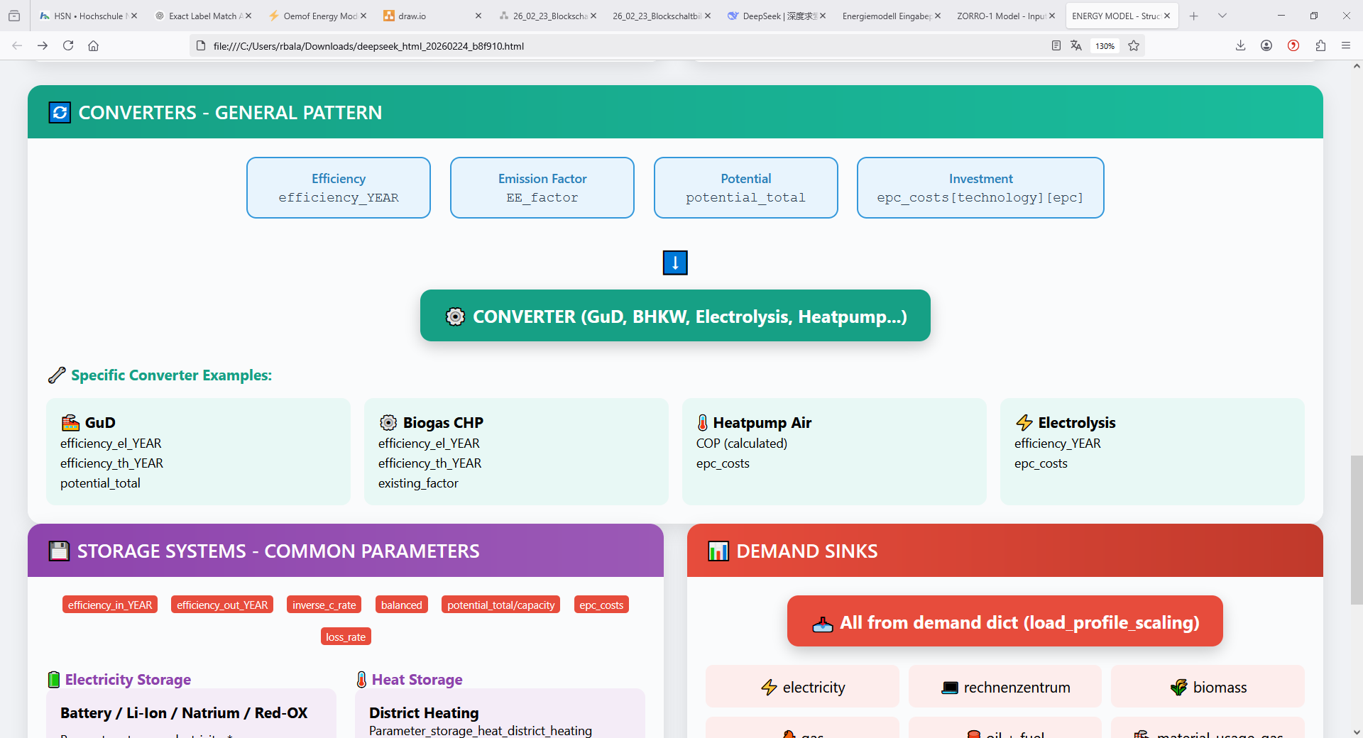
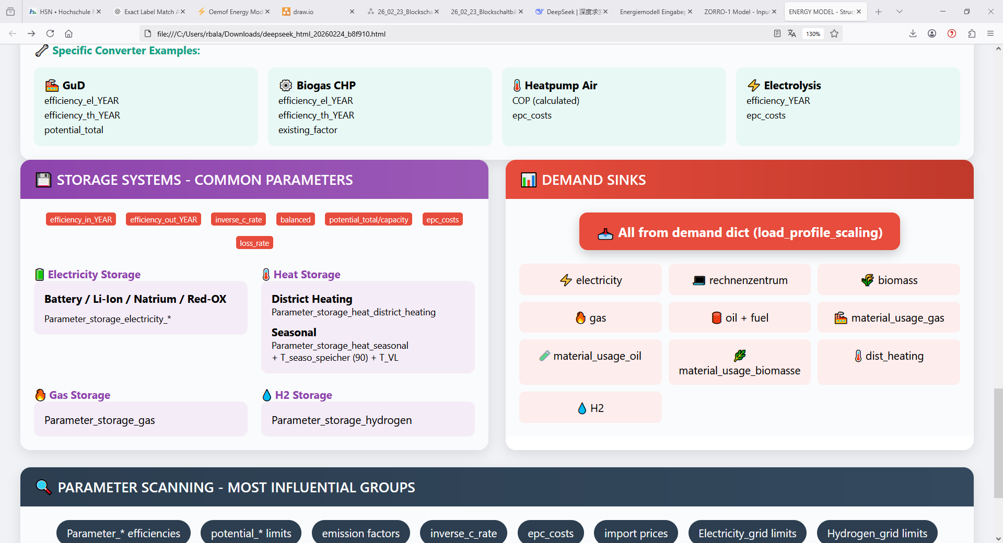

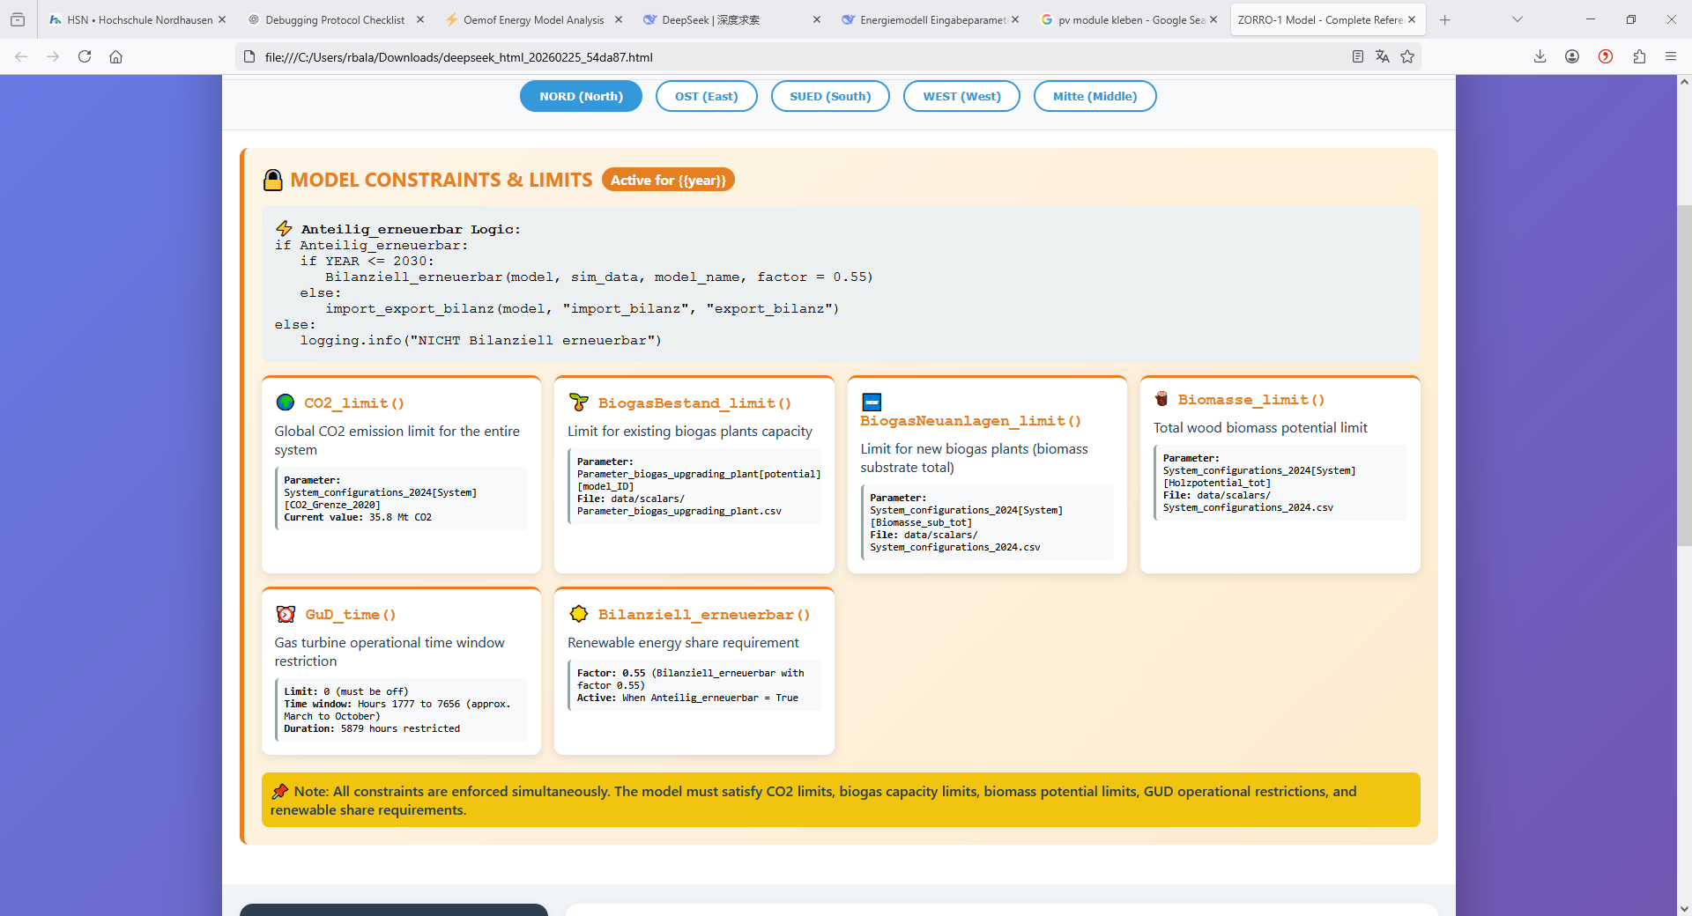
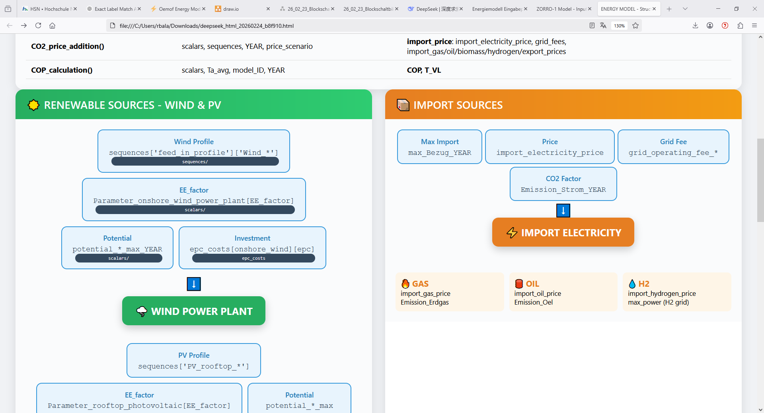

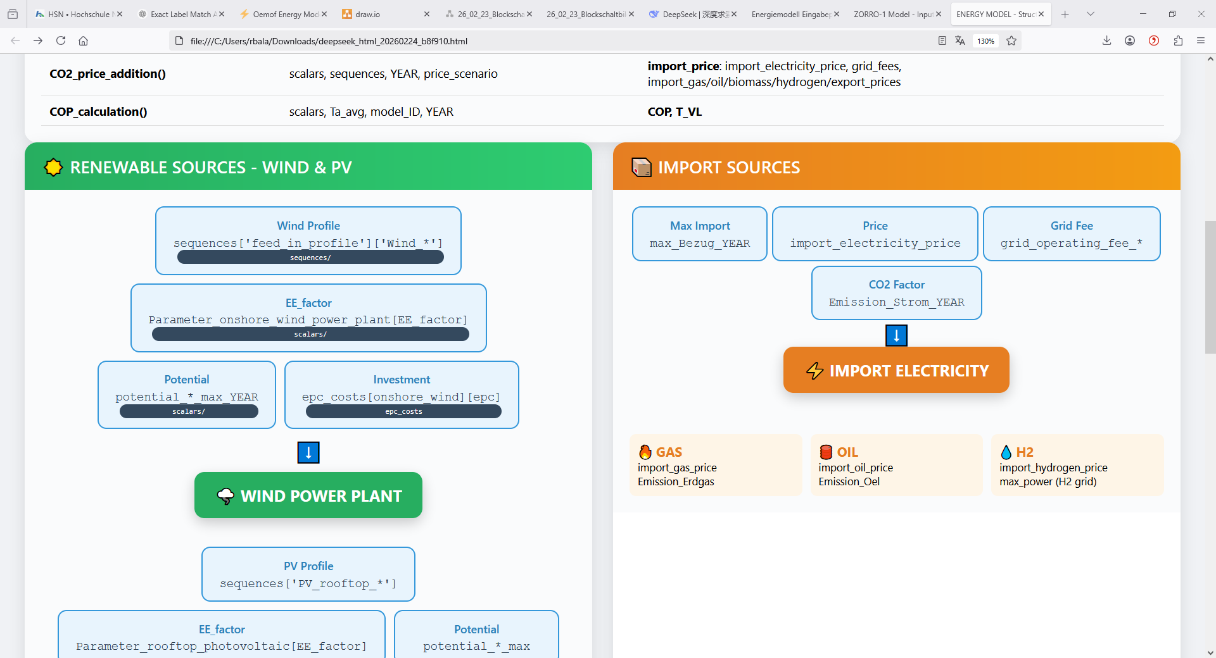
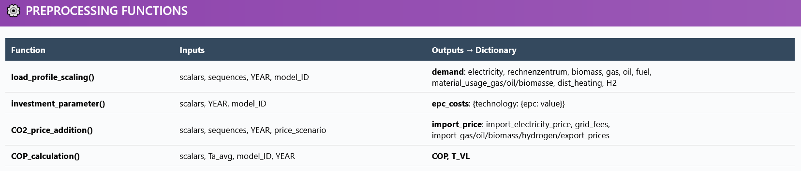
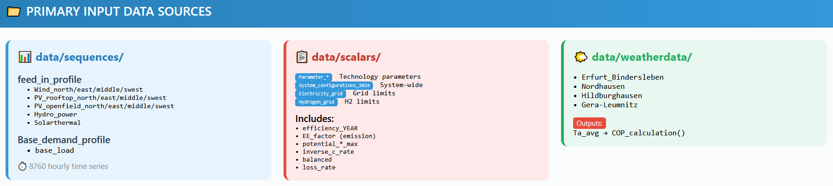
Basisszenario_1(PERMUTATION) → YEAR_modelID
Year: 2020-2045
ELECTRICITY
IMPORT SOURCES
RENEWABLE SOURCES

ZORRO II – Data Flow and Parameter Overview

